MainActivity.kt:-

package com.example.myapplication  
  
import android.content.Intent  
import androidx.appcompat.app.AppCompatActivity  
import android.os.Bundle  
import android.widget.Button  
import android.widget.Toast  
  
class MainActivity : AppCompatActivity() {  
 override fun onCreate(savedInstanceState: Bundle?) {  
 super.onCreate(savedInstanceState)  
 setContentView(R.layout.*activity_main*)  
  
 var btnstart:Button=findViewById(R.id.*start*)  
 var btnstop:Button=findViewById(R.id.*stop*)  
 btnstart.setOnClickListener **{** var intent1:Intent=Intent(*applicationContext*,MyService::class.*java*);  
 startService(intent1);  
 Toast.makeText(*applicationContext*,"Service has started....",Toast.*LENGTH_LONG*).show()  
 **}** btnstop.setOnClickListener **{** var intent1:Intent=Intent(*applicationContext*,MyService::class.*java*);  
 stopService(intent1);  
 Toast.makeText(*applicationContext*,"Service has stoped....",Toast.*LENGTH_LONG*).show()  
 **}** }  
}

Myservice.kt

package com.example.myapplication  
  
import android.app.Service  
import android.content.Intent  
import android.content.res.Resources  
import android.media.MediaPlayer  
import android.os.IBinder  
  
class MyService : Service() {  
 var mp:MediaPlayer= MediaPlayer();  
 override fun onBind(intent: Intent?): IBinder? {  
 return null;  
 }  
 override fun onStart(intent: Intent,id:Int){  
 super.onStart(intent,id)  
 mp=MediaPlayer.create(this,R.raw.*sample_music*);  
 mp.start();  
 }  
 override fun onDestroy(){  
 super.onDestroy()  
 mp.stop()  
 }  
}

Output:-

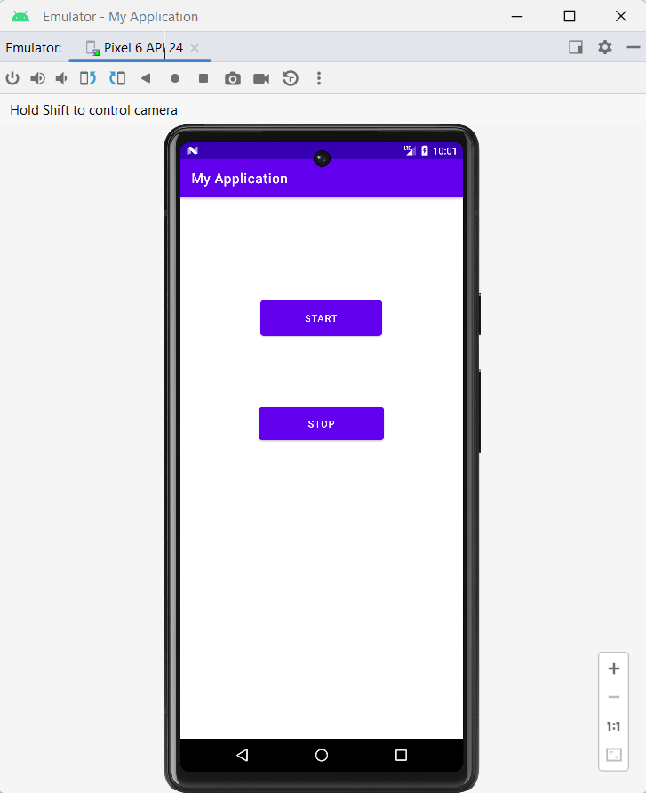

Service Start:-

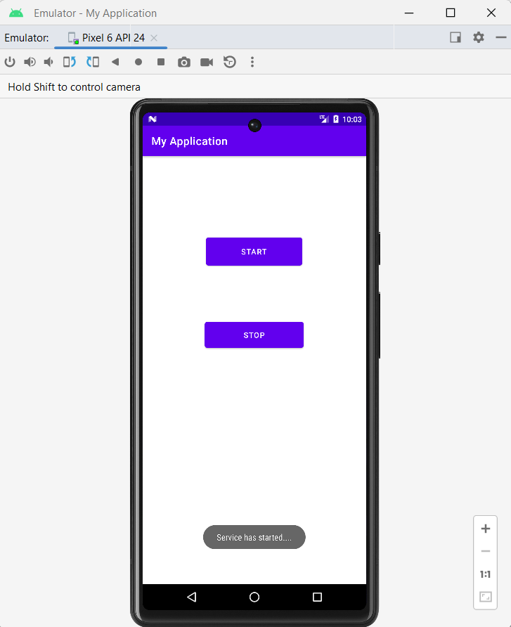

Service Stop:-

